# 

# Digital Marketing Strategy for Mahindra & Mahindra Ltd.

Mahindra & Mahindra Ltd. (M&M) is a prominent global player in sectors like automotive, agribusiness, aerospace, and IT. A comprehensive digital marketing strategy for M&M would need to focus on brand awareness, customer engagement, lead generation, and positioning the company as an innovative leader in its industry. Below is a detailed breakdown of the components of a digital marketing strategy for M&M.

# * Brand Study, Competitor Analysis & Buyer's/ Audience's Persona:

A Brand Study, Competitor Analysis, and Buyer's/Audience Persona are critical components for developing a comprehensive marketing strategy.

## Brand Study:

A brand study involves assessing how a brand is perceived by its target audience and how it differentiates itself from competitors. This study can help you understand the current position of your brand and what areas need improvement.

Key components:

Brand Identity: The visual and emotional elements that represent the brand (logo, colors, typography, etc.).

Brand Positioning: How the brand is positioned in the market, compared to competitors. Brand Message: The core message or value the brand communicates to its audience.

Brand Perception: Customer feedback and sentiment toward the brand.

Brand Equity: The value of the brand based on consumer perception, loyalty, and associations.

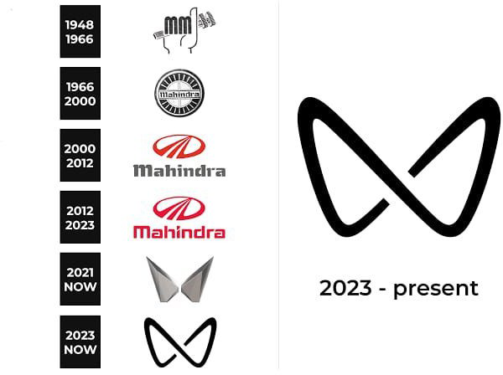

(e.g., sales, market share).

## Competitor Analysis:

Competitor analysis helps you understand your competition’s strengths, weaknesses, and strategies. This allows you to identify opportunities for differentiation and improvement.

Key components:

Identifying Competitors: Direct competitors (offering similar products/services) and indirect competitors (substitute products or services).

Product/Service Comparison: Compare features, pricing, quality, and value propositions. Market Positioning: How your competitors are positioned in the market (premium, budget, etc.).

Marketing Strategies: Examine their online presence, advertising campaigns, and content marketing strategies.

SWOT Analysis: Assess their strengths, weaknesses, opportunities, and threats.

## Buyer's/Audience Persona:

A buyer persona is a semi-fictional representation of your ideal customer. It helps you understand who your audience is, what their needs and pain points are, and how they make purchasing decisions.

Key components:

Demographic Information: Age, gender, location, income level, education, occupation. Psychographics: Interests, hobbies, values, beliefs, lifestyle choices.

Behavioral Traits: Buying patterns, purchase frequency, decision-making process.

Goals and Challenges: What the persona aims to achieve (goals) and the obstacles they face (challenges).

Pain Points: Problems the persona faces that your product or service can solve.

Preferred Communication Channels: How they prefer to receive information (social media, email, in-person, etc.).



# * SEO & Keyword Research:

SEO (Search Engine Optimization):

SEO refers to the practices and techniques used to improve the visibility of a website or content on search engine results pages (SERPs). It involves both on-page and off-page factors that influence rankings.

## * Keyword Research:

Brainstorm Seed Keywords: Think about the general topics relevant to your business or content.

Use Keyword Research Tools: Tools like Google Keyword Planner, SEMrush, Ahrefs, or Ubersuggest can help find relevant keywords based on search volume, competition, and intent.

Analyze Search Intent: Understand the intent behind a search. Are people looking to buy (commercial intent), learn (informational intent), or find something (navigational intent)?

Check Competition: Analyze what keywords your competitors are ranking for.

Long-tail Keywords: Focus on longer, more specific phrases (long-tail keywords), which tend to have lower competition but can drive more qualified traffic.

# * Content Ideas And Marketing Strategies:

## Content Ideas:

Create step-by-step guides to help your audience solve specific problems. This can be in the form of blog posts, videos, or infographics.

Example: "How to Create a Successful Social Media Strategy for Your Brand." User-Generated Content (UGC)

Encourage customers to share their experiences with your product or service. Feature their posts on your social channels or website.

Example: A campaign where users share photos or testimonials about how they use your product.

Behind-the-Scenes Content

Show how your product is made, or give a behind-the-scenes look at your company culture. This builds authenticity and transparency.

Example: A "Day in the Life" series featuring different team members. Case Studies and Success Stories

Share real-life examples of how your product/service helped customers. This provides proof of value and builds trust.

Example: "How Our Marketing Tool Helped Brand X Increase Engagement by 50%."

Industry News and Updates

Share timely and relevant news from your industry. This keeps your content fresh and positions you as an authority.

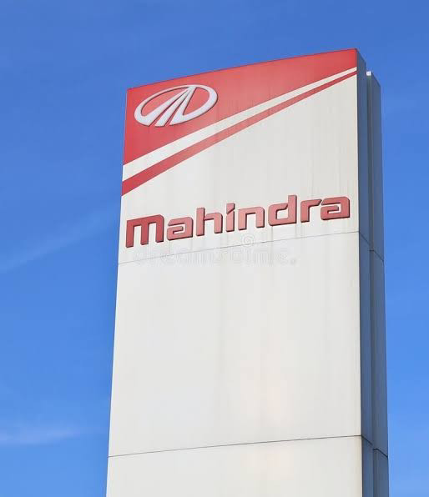

## * Marketing Strategies:

Focus on optimizing your content for search engines by using targeted keywords, meta descriptions, and high-quality content.

Use tools like Google Analytics and Ahrefs to analyze keywords and optimize your blog posts. Influencer Marketing

Collaborate with influencers in your niche to promote your products to a wider audience. Choose micro-influencers for more niche engagement.

Example: Send your product to an influencer and ask them to review it on social media. Social Media Marketing

Focus on building a presence on platforms where your target audience spends their time. Create a mix of educational, entertaining, and promotional posts.

Utilize paid ads to boost visibility.

Encourage your customers to refer others by offering incentives like discounts or free products/ services.

Example: "Get 10% off your next order when a friend makes their first purchase."

# * Content Creation And Curation:

Content creation and curation are essential aspects of building an online presence, engaging audiences, and promoting ideas, products, or services.

## Content Creation:

This is the process of generating original content, which can take various forms depending on the medium you're using. It’s about producing value for your audience through your own ideas and expressions.

Types of Content:

Written: Blogs, articles, social media posts, eBooks, newsletters. Visual: Graphics, infographics, photos, videos, memes.

Audio: Podcasts, voiceovers, music. Interactive: Polls, quizzes, webinars. Tips for Effective Content Creation:

Know your audience: Understand their needs, preferences, and challenges.

Be authentic: Content that reflects your true voice or brand values tends to connect better. Provide value: Solve a problem, entertain, or inform.

Consistency is key: Regular posting keeps your audience engaged.

Use the right tools: From design apps to content planners, using the right tools can save time and boost creativity.

## Content Curation

Curation involves finding, organizing, and sharing relevant content created by others. It helps provide value to your audience without always needing to produce everything from scratch.

* 1. Industry News: Sharing the latest trends, articles, or reports in your field.
  2. User-Generated Content: Reposting content created by your audience or customers. 3.Third-party Resources: Curating valuable resources, guides, or tips from other experts.

## * Benefits of Content Curation:

1. Time-saving: You don’t have to create every piece of content yourself.
2. Builds community: Sharing other people's content helps build relationships and credibility.
3. Diversification: Offers variety, showing your audience you’re plugged into a broader conversation.
4. Enhances credibility: Sharing authoritative sources can position you as a trusted curator in your field.
5. Balance curation and creation: A healthy mix ensures you're not overly reliant on others' work.Ensure the curated content aligns with your audience’s interests